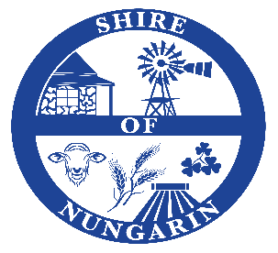
PUBLIC NOTICE
MOSQUITO FOGGING
December 17, 18 and 19, 2025

Please be advised that the Shire of Nungarin will be conducting mosquito fogging during the period December 17 – 19, 2025.

Mosquito fogging will be done at dusk instead of early morning due to the noise produced by the fogging machine.

During fogging it is recommended that households close all windows and doors and reopen them 30 minutes after the fogger has passed.
It is also recommended that anyone with fishponds outside should cover them for the same period.

The Shire also supplies mosquito tablets for septic tanks to help further combat mosquitos.
These tablets are free and available at the Shire of Nungarin admin building between 8.00am and 4.00pm.

Please don’t hesitate to call David Dhu – Acting Works Manager or the Shire Office if you require any further information.

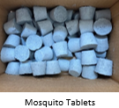
David Dhu 0484 578 635
Shire Office 9046 5006

